**ID6501 Responsive Web Design**

**Project 1**

Minhua Cao

2174973

# Sitemap

A comprehensive plan for the information architecture of a Taylor Swift’s Concert website consisting of four web pages, along with a flowchart and rationale for the page flow:

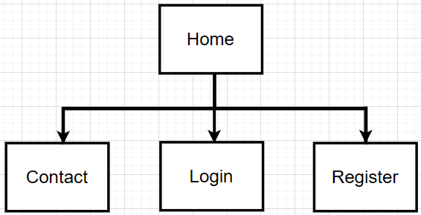

* **Home Page**

1. This is the main page for users when they visit the website.
2. From the homepage, users can navigate to other page, like “Contact”, “Login”, or “Register”.

* **Contact Page**

1. Users can navigate to the "Contact" page from the home page to find information on how to get in touch with the concert organizers, such as email addresses, phone numbers, and address.
2. Users also can fill up the “Send Us A Message” form to get in touch with the concert organizers.

* **Login**

1. Users can navigate to the "Login" page from the home page, if they already have an account with the website.
2. Provides a form for existing users to enter their credentials (email and password) to access their accounts.

* **Register**

1. Users can navigate to the "Sign Up" page from the home page, if they are new to the website and want to create an account.
2. Offers a registration form where users can enter their details such as username, email, password, and confirm password to create an account.

**Why I choose Home page be the main page?**

* Home page is often the first page visitors see when they arrive at a website.
* Home page contains links to other page.
* Home page provides an overview of the website's content, highlighting key features.

**Why I choose that color theme, font, design style?**

I chosen this color theme, font, and design style because I wanted to create a visual experience for users that matched Taylor Swift’s albums. Design style to ensure users easy navigation and a seamless user experience. Font chosen for users easy to read.

# Wire Frame

### Home Page

Home page including the banner, navigation bar, text box, flex box. Which the main page of this website, provides an overview of upcoming concerts and singer’s information.

* Banner with the concert title.
* Navigation bar include the logo, home, contact us, sign up, login page for users easy to navigate to other page.
* Text bx include the singer’s title and singer’s description.
* Flex box includes different concert themes. The concert theme Flex Box contains concert images, information and buttons.

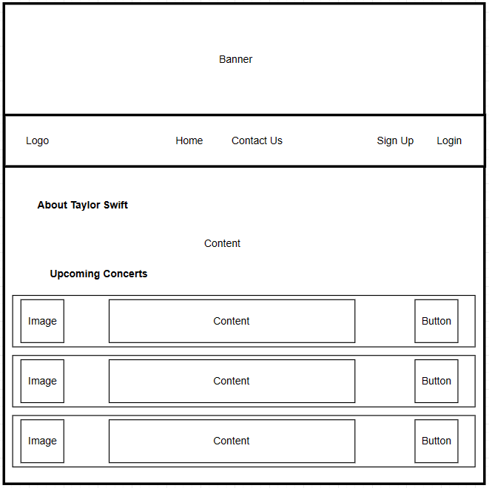

### Contact Us Page

Contact Us page include the banner, navigation bar, message form, and the flex box. Which provide the page and form for the users when they have some issues.

* Banner with the concert title.
* Navigation bar include the logo, home, contact us, sign up, login page for users easy to navigate to other page.
* Message form include the text box that need users to fill the information (full name, email, and message) and click the button (send message) to submit the form to the organizer.
* Flex box include the information of organizer’s address, phone number, and email.

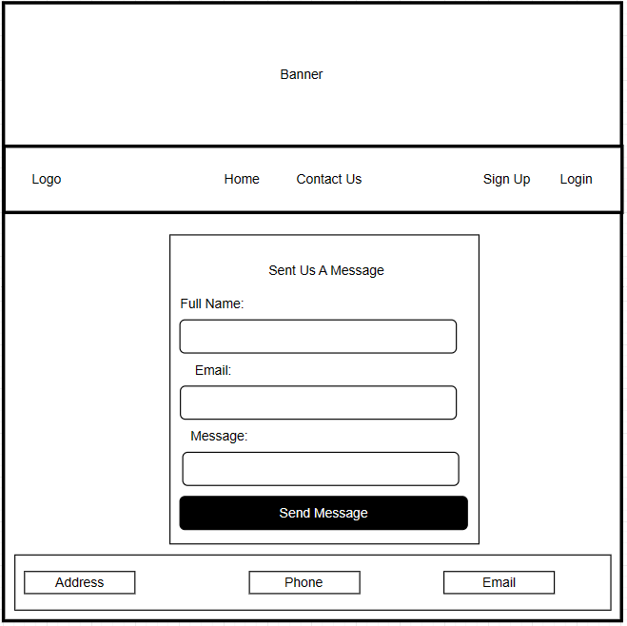

### Login Page

Login page include the background image, navigation bar, login form, message link, and text box. Which provide the page for users login to their account.

* Navigation bar include the logo, home, contact us, sign up, login page for users easy to navigate to other page.
* Background image.
* Login form include email and password that users need to enter their email and password to login their account. Then click to button (login) to login their account.
* Message link for who does not the account to go to Sign Up page to create their account.

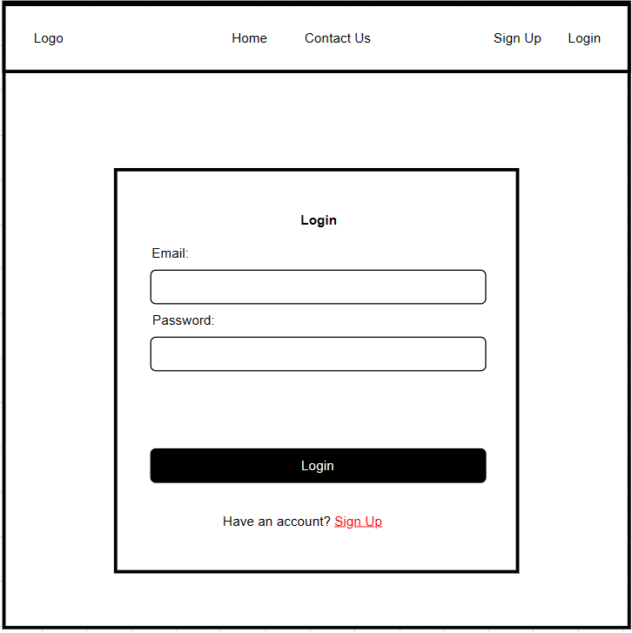

### Sign Up Page

Sign Up page include the background image, navigation bar, register form, message link, and text box. Which provide the page for users to create their account.

* Navigation bar include the logo, home, contact us, sign up, login page for users easy to navigate to other page.
* Background image.
* Sign up form need fill up information (username, email, password, confirm password) of the from to create their account. Then click to button (Sign Up) to create their account.
* Message link for who have an account to go to Login page to login to their account.

